**Tests**

**Correct inputs**

1.) let fun s(e2) = let val d = if true then s else d in s end in ! {s ; 2} end ;

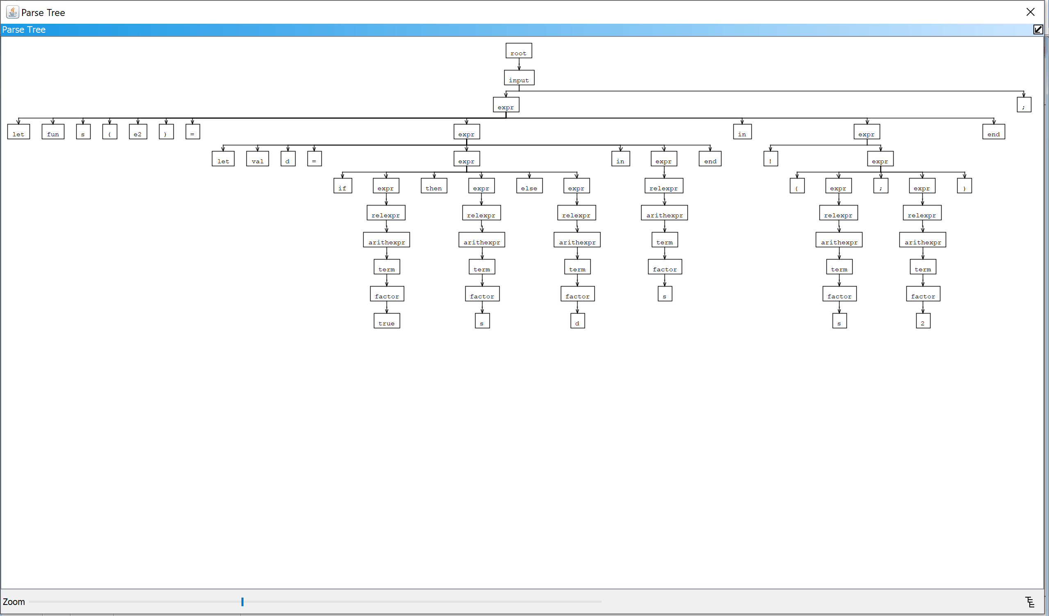

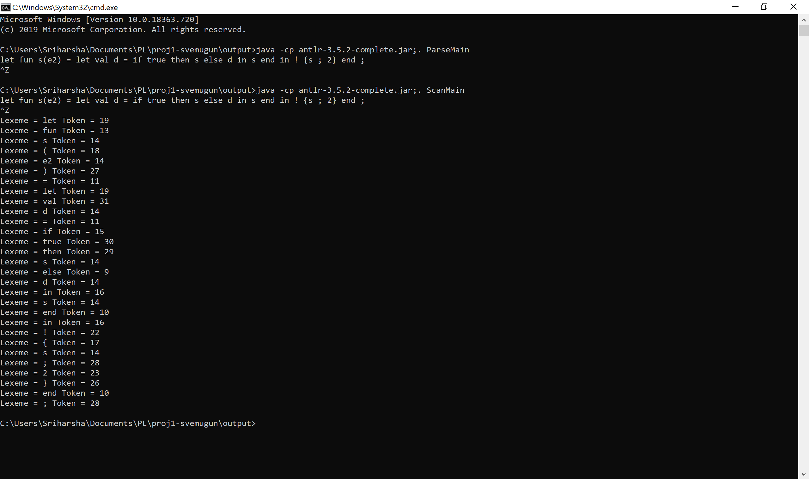

2.) let val s= s := y*2+8/z in while ! s+y do s end;

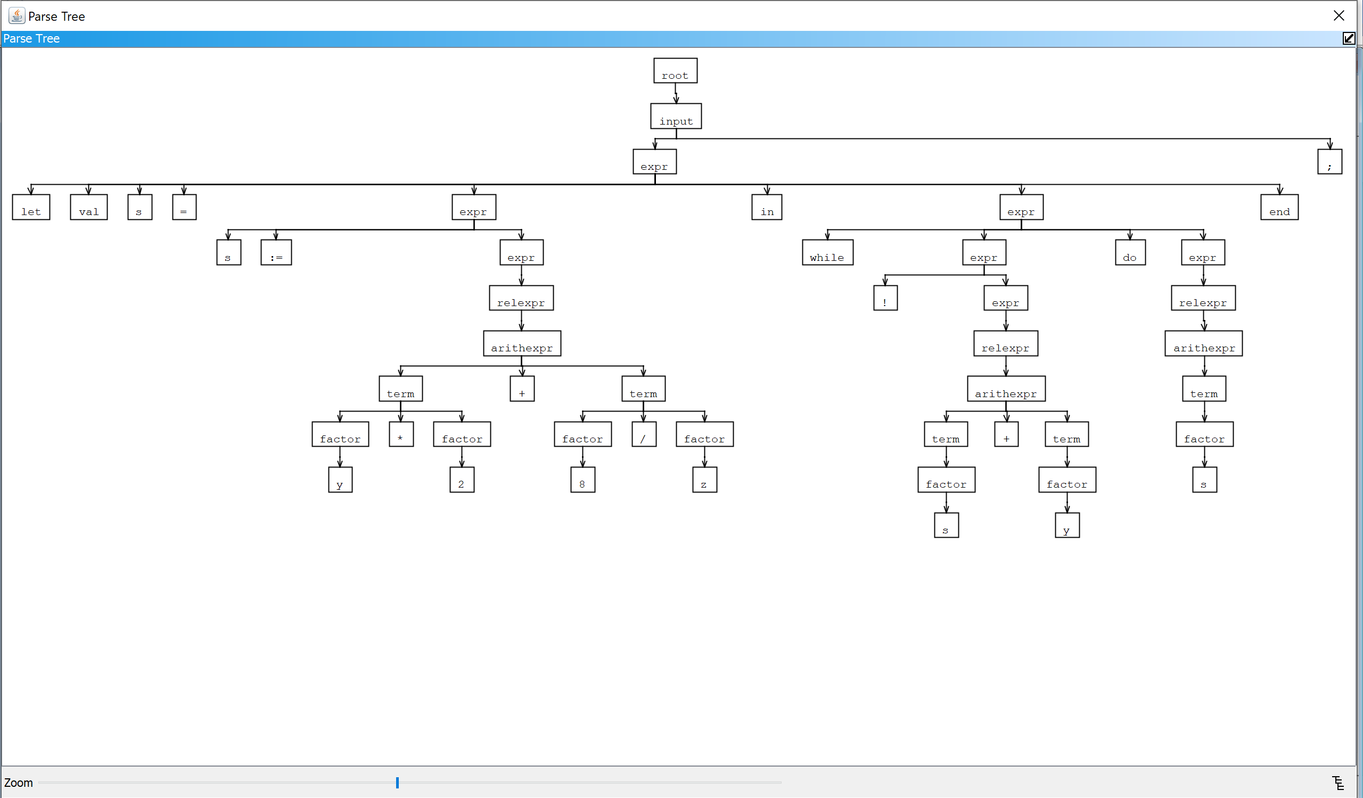

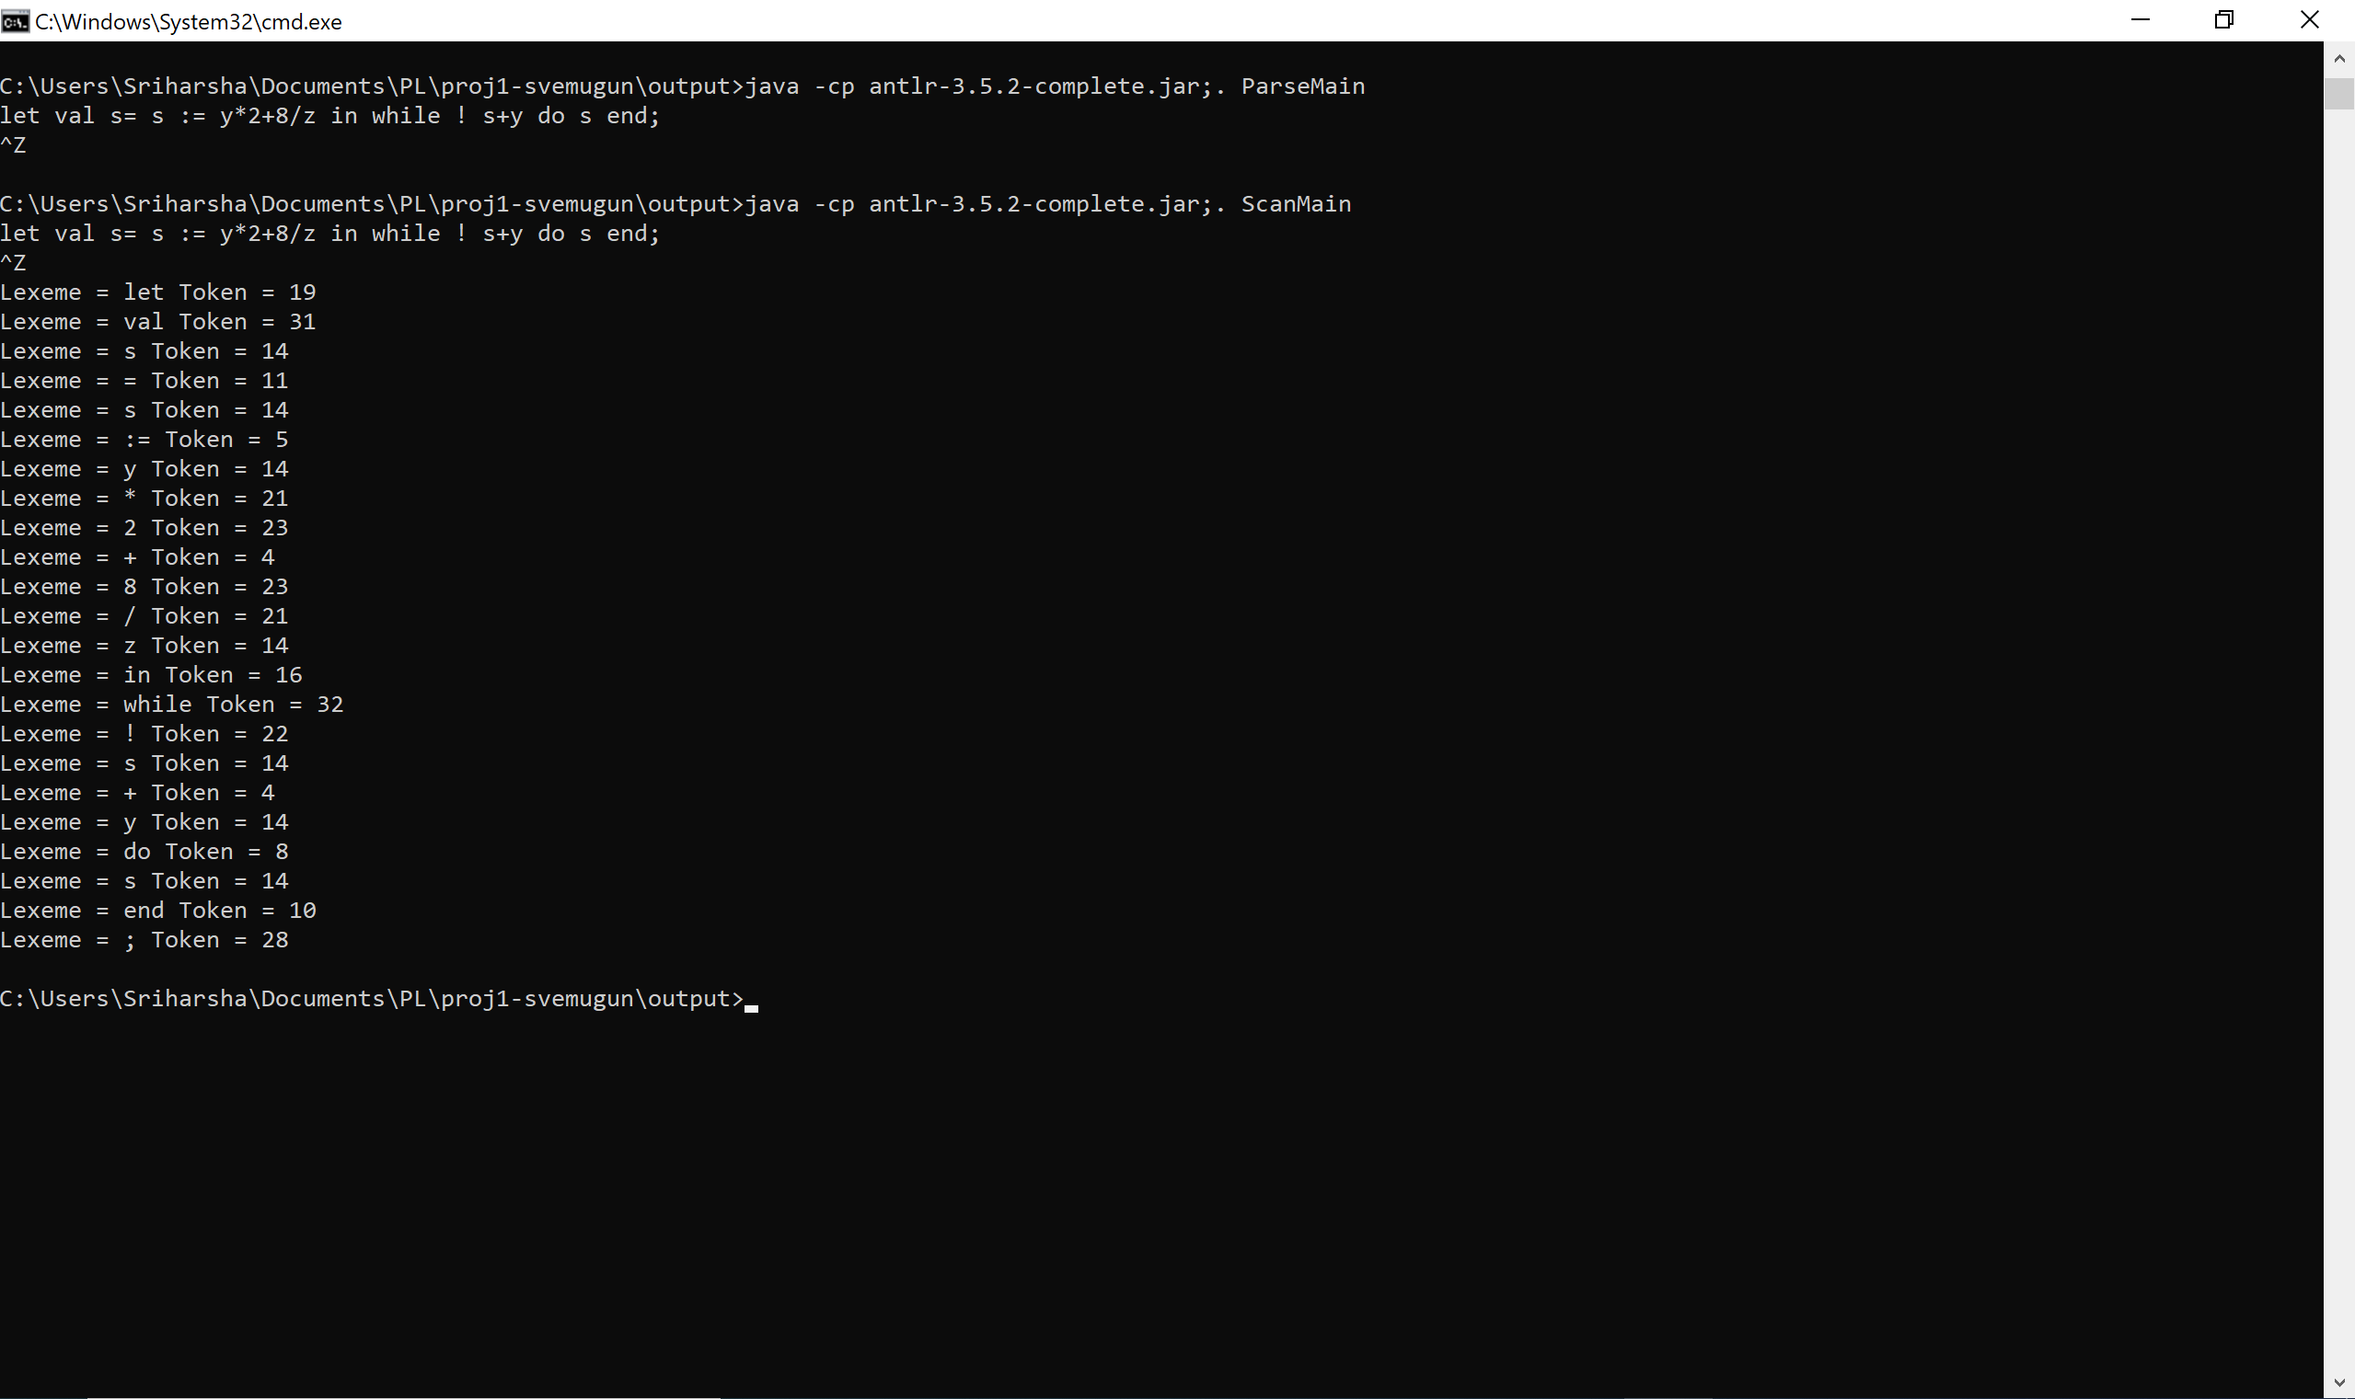

3.) if s&r then s-1 else r:=r*5 ;

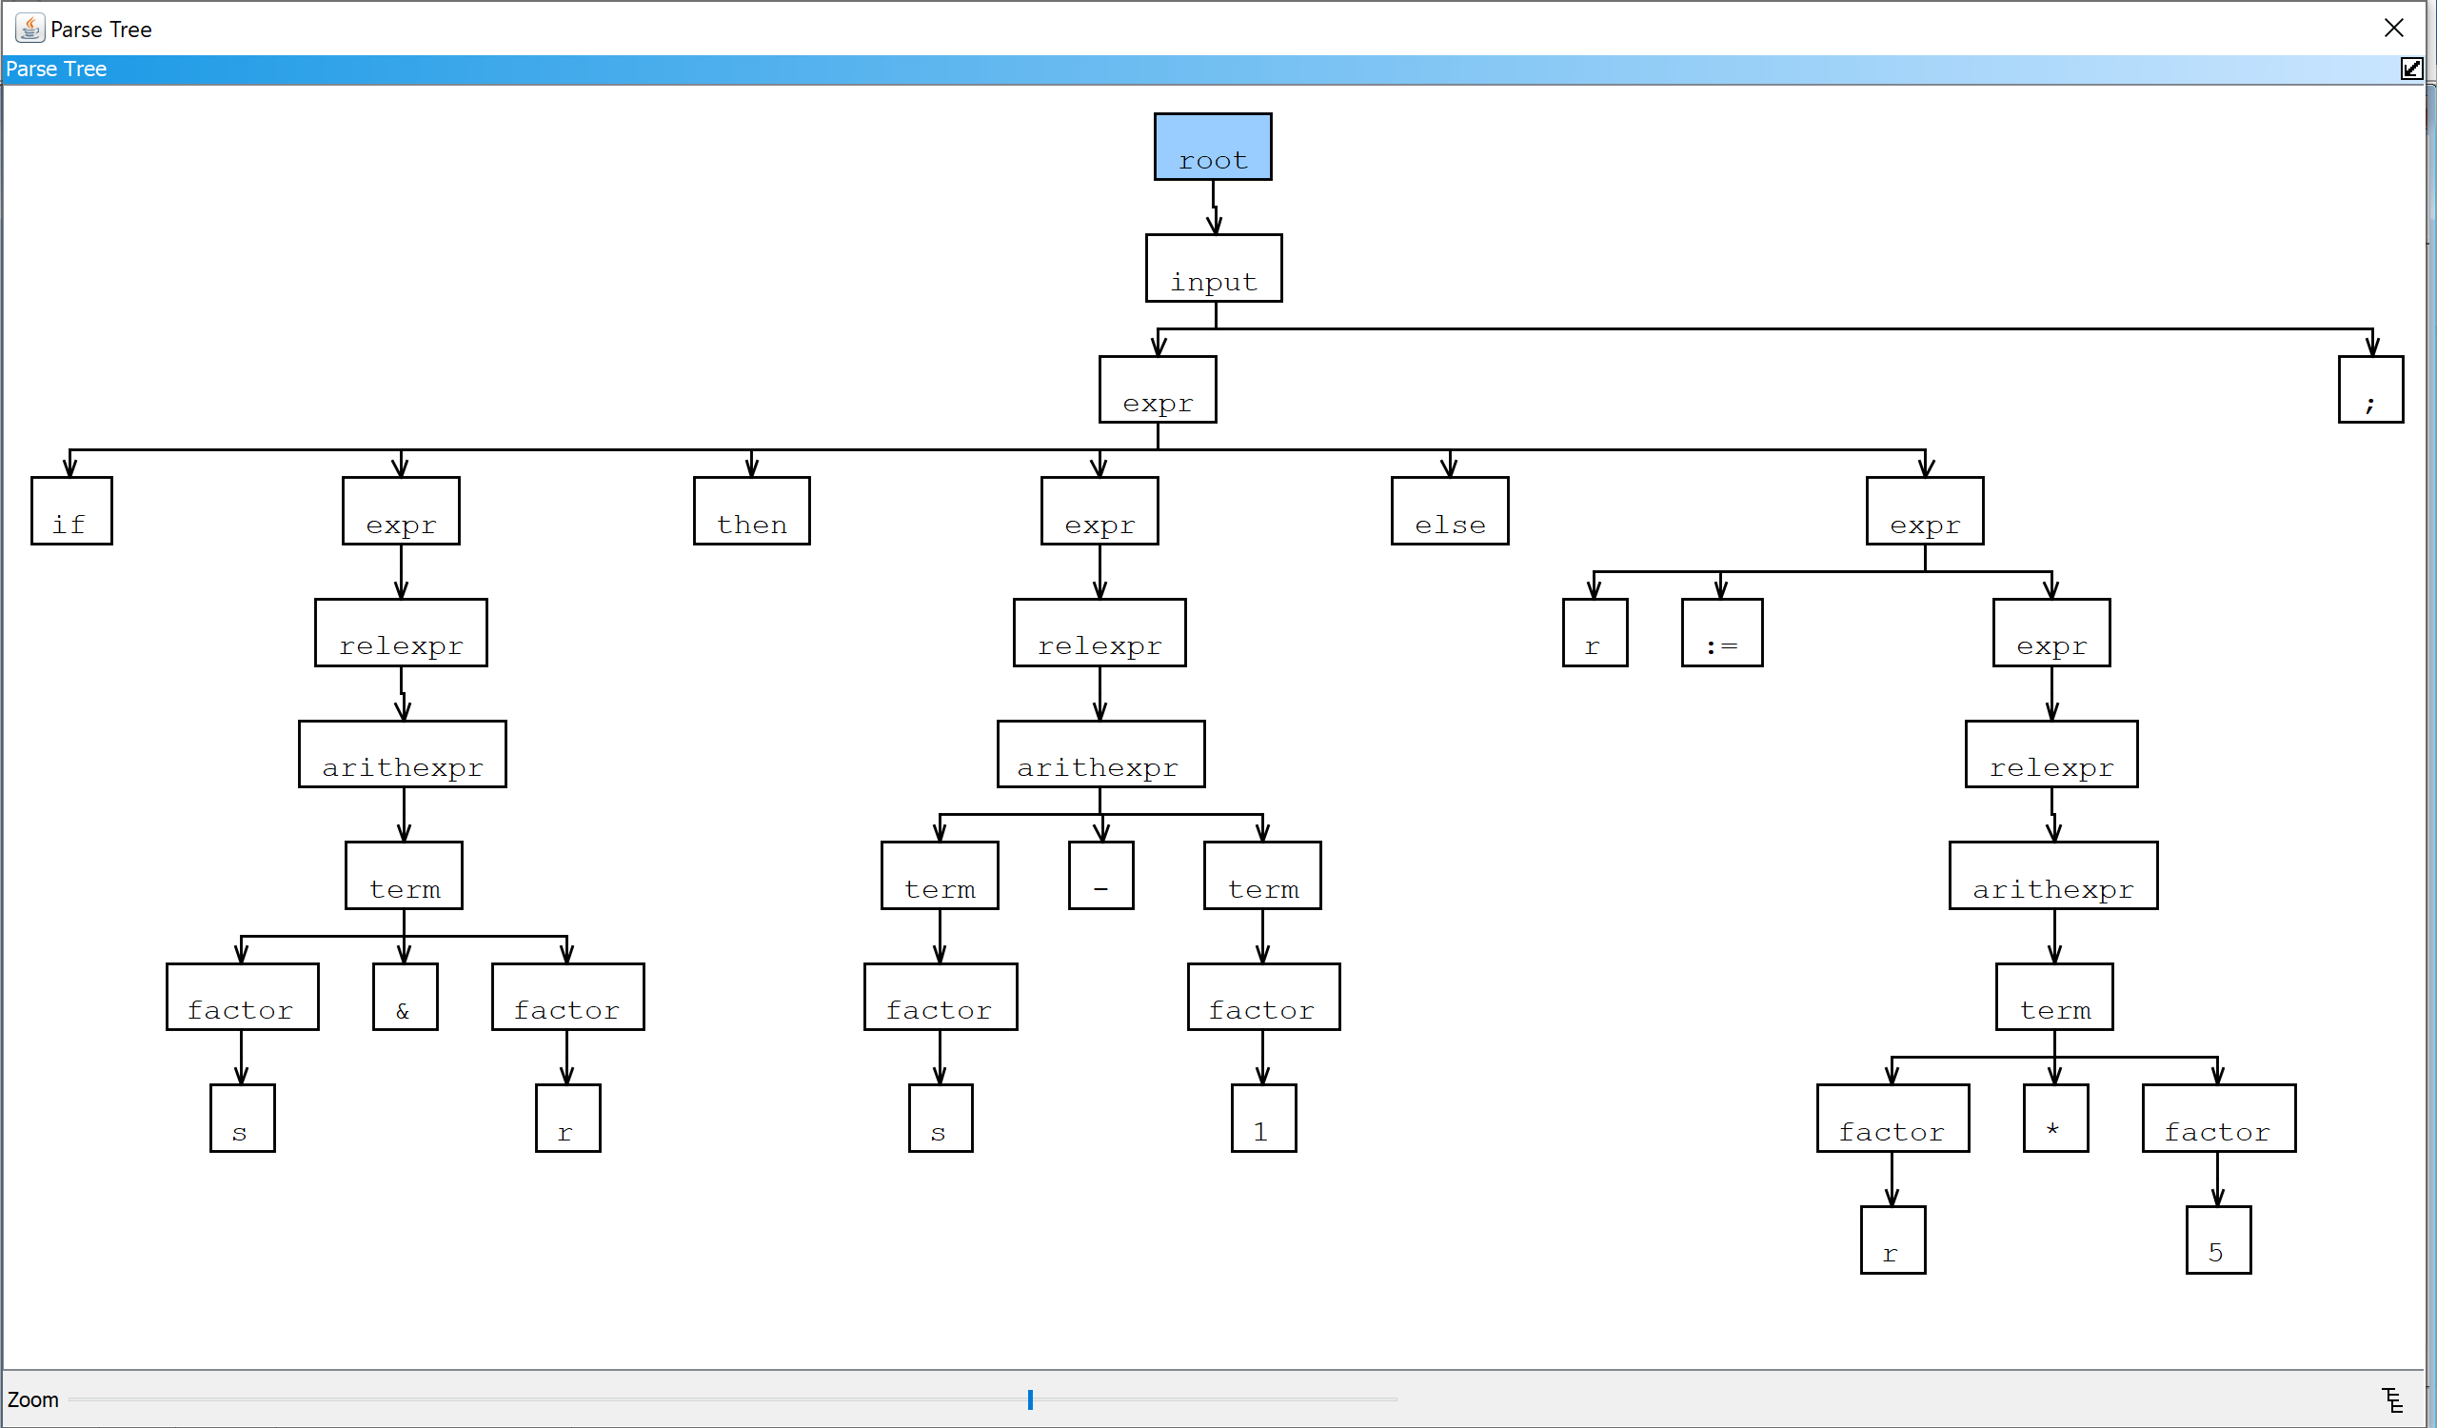

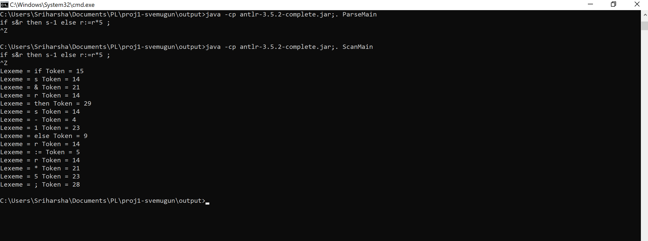

4.) while true do if false then y(s(2)) else y+3;

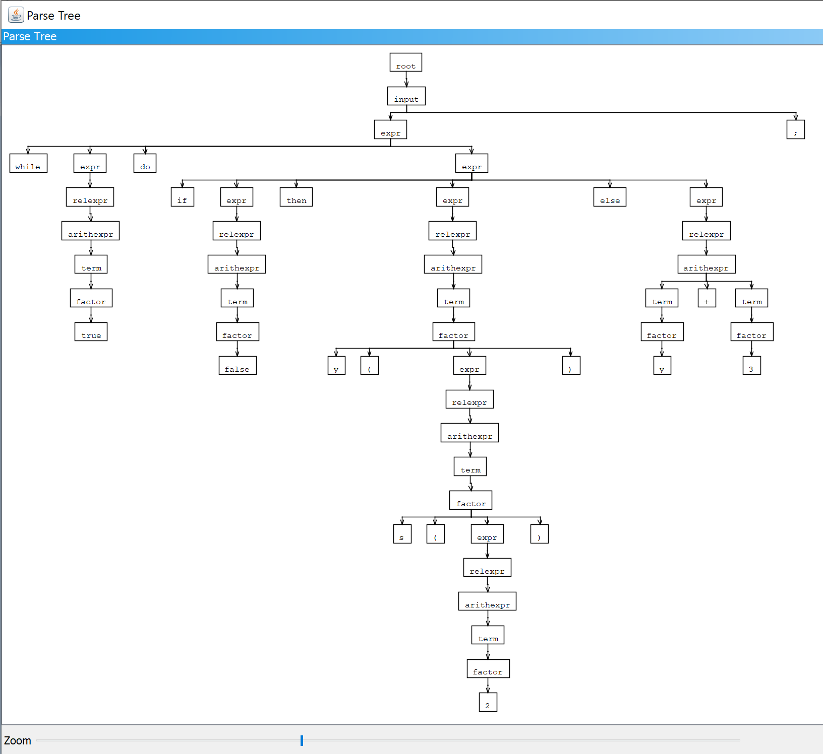

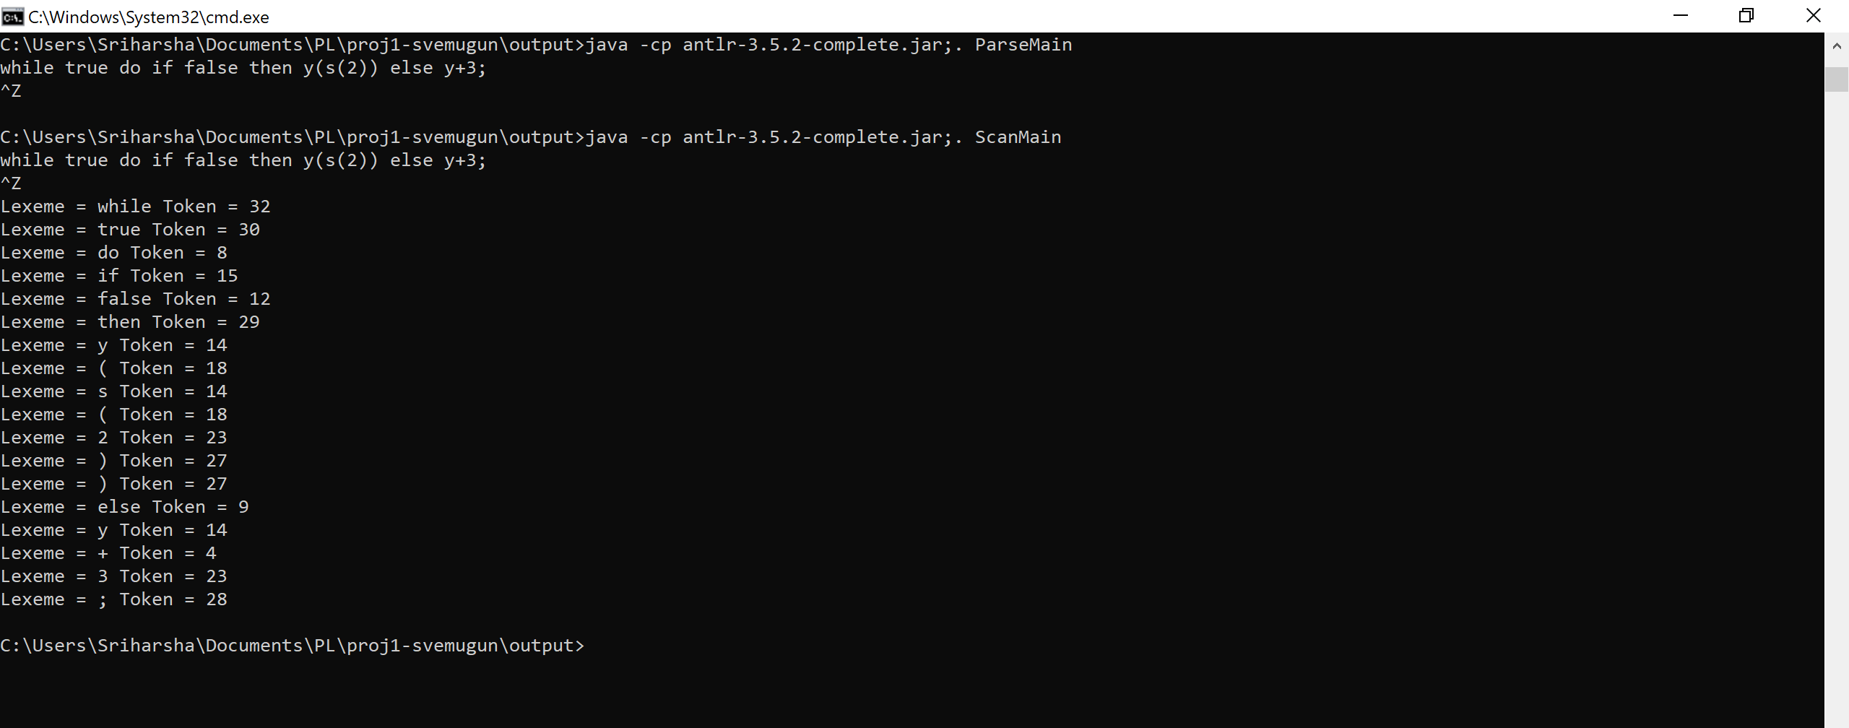

**Wrong inputs:**

5.) while true do if false then y(s(2)) else {y(:={3})};

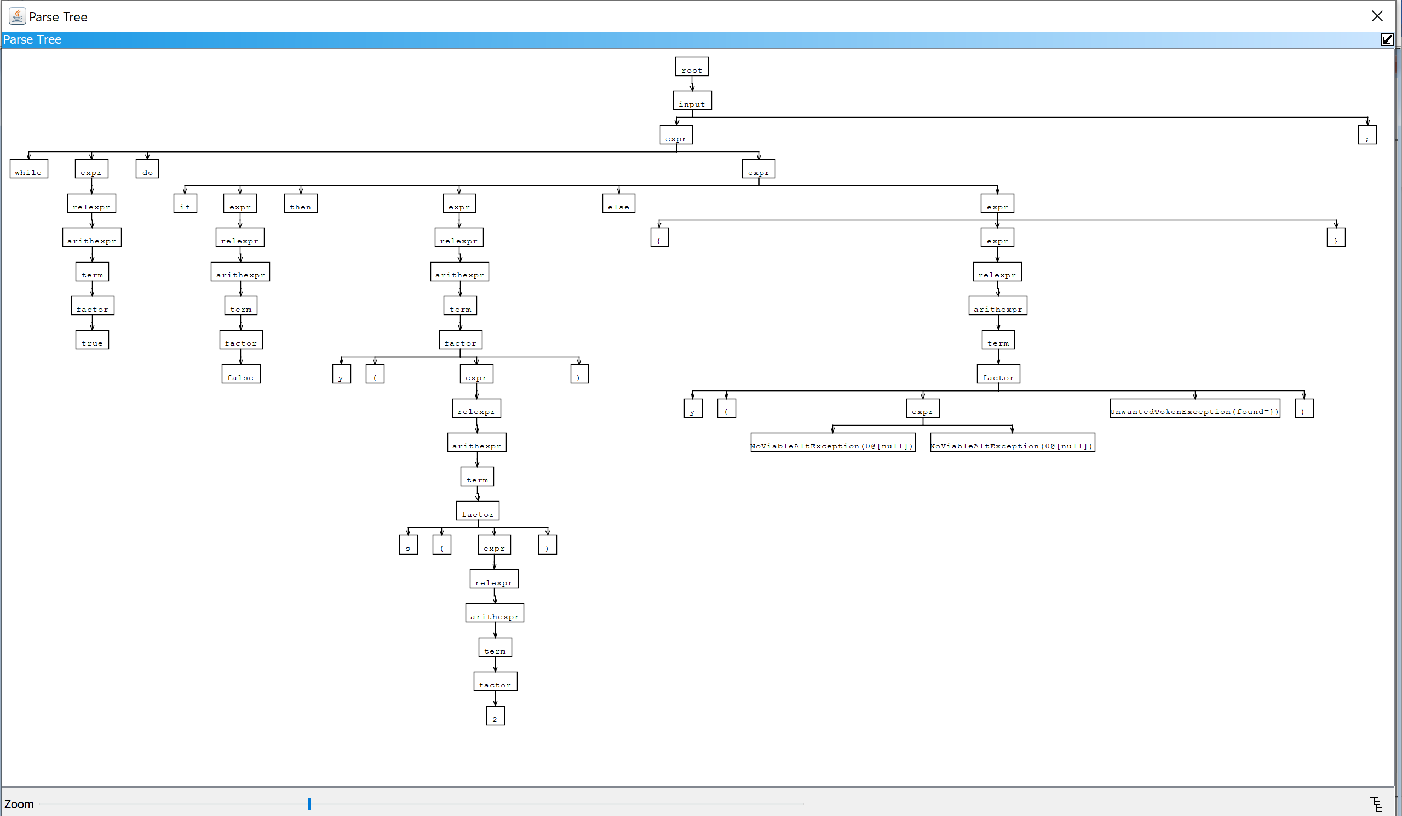

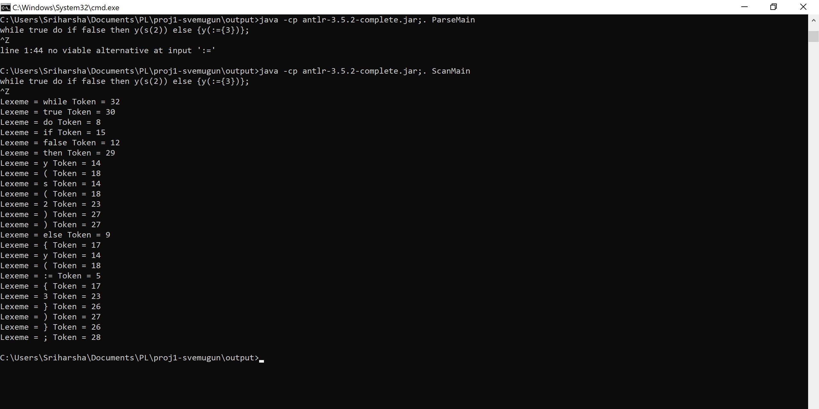

6.) let val s= 2 in while !y {:= z} do s end;

